HW2a

YL5090

Yuqiong Li

SEG2- Write up

# **Preprocessing:**

1. Order the speed data as time
2. Remove outliers
   1. This step is done by removing all points that are 3 standard deviation away from sample mean.
3. For NaN values, fill it with the last valid value before it
4. The circle of seasonality is 144. Remove seasonality by subtracting the value 144 time stamp away. Then remove the first 144 values as they are nan now.

Identification:

After cleaning data, now identify an ARIMA(p, d, q) model.

Step 1: First plot the time-series



After differentiating:



Use the Augmented Dickey-Fuller test to check existence of unit root:

ADF statistic: -21.175392

p-value: 0.000000

Critical Values:

1%: -3.431

5%: -2.862

10%: -2.567

Conclusion:

1. Differentiated data doesn’t seem to fit any upward or downward trend.
2. Augmented Dickey-Fuller test rejects null hypothesis. Thus no unit root. No time dependent structure.
3. Thus, now conclude stationary. Set d = 0.

# Step 2: Identify AR or MA process by plotting ACF and PACF for different lag values.

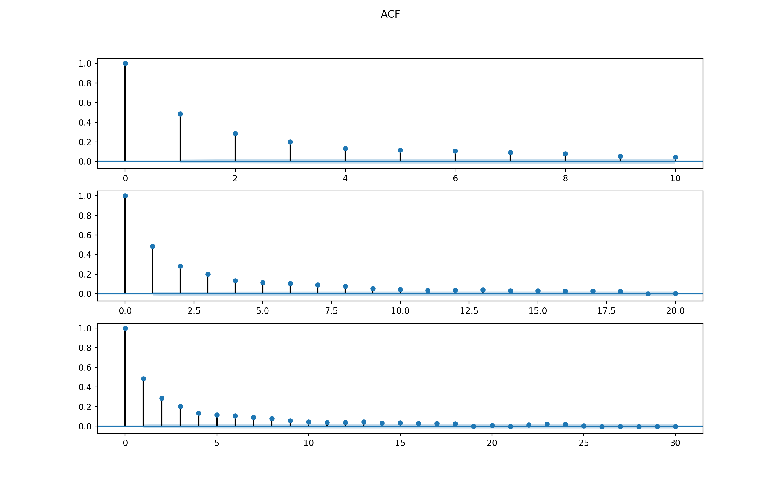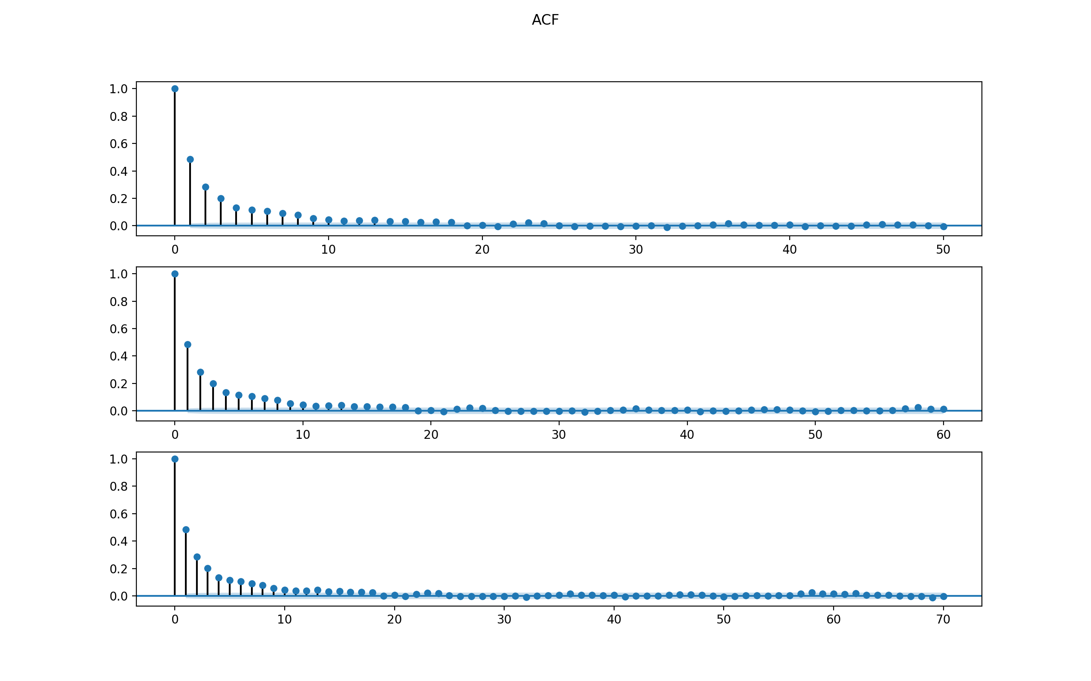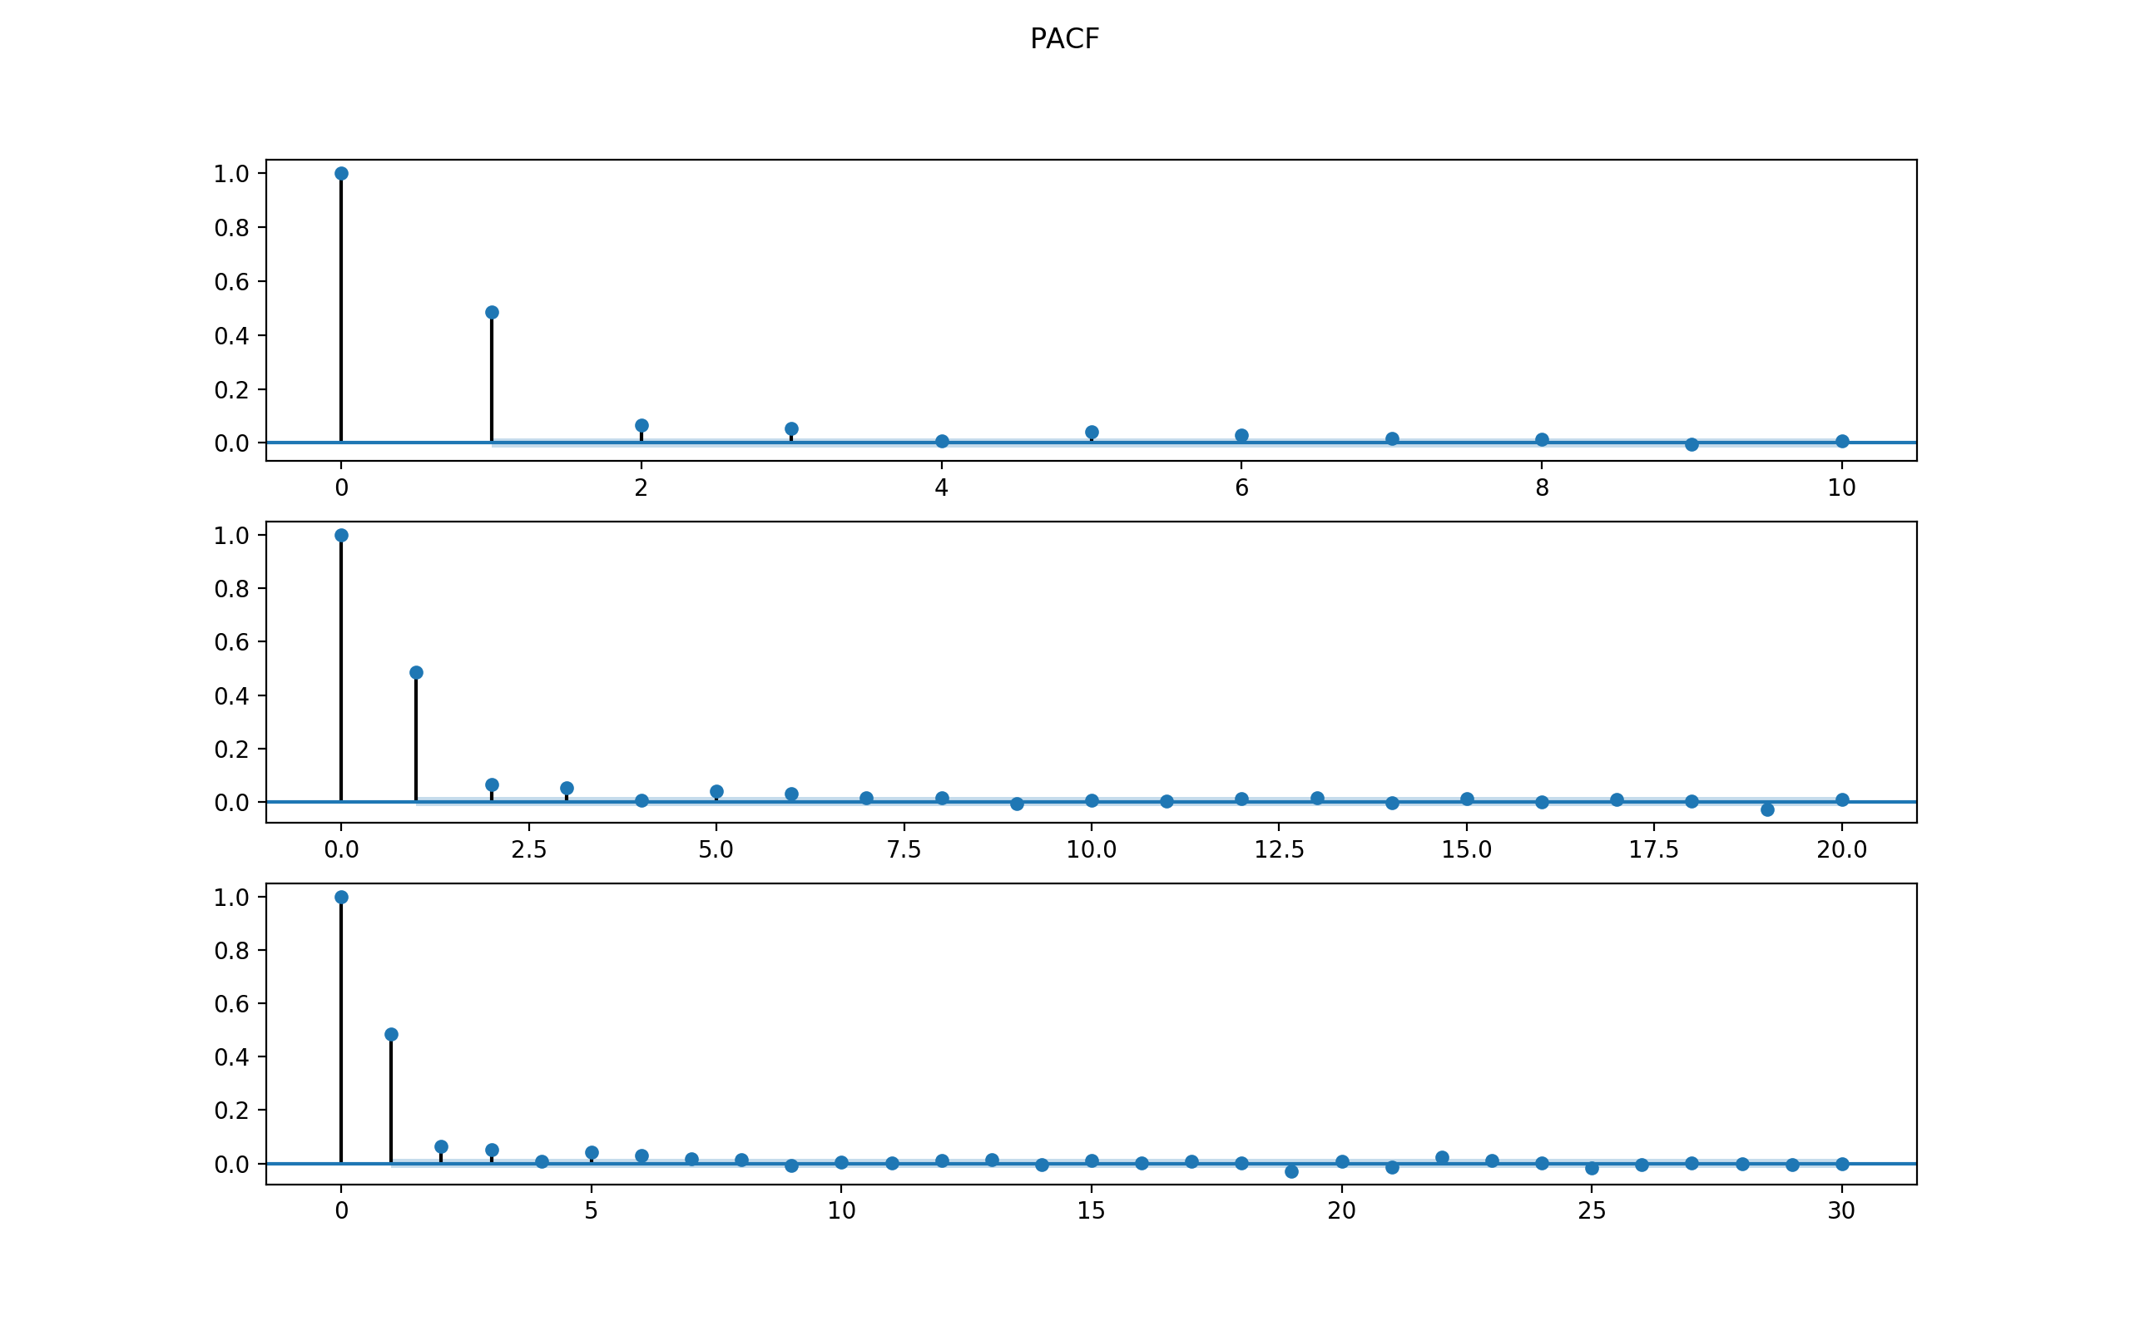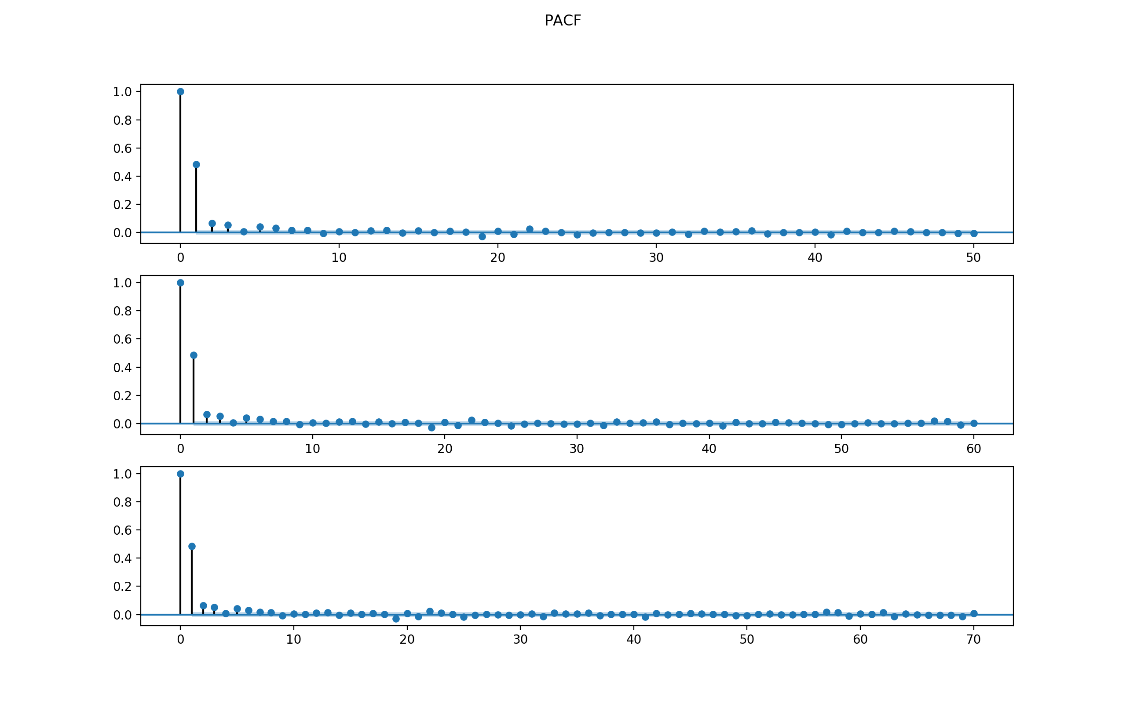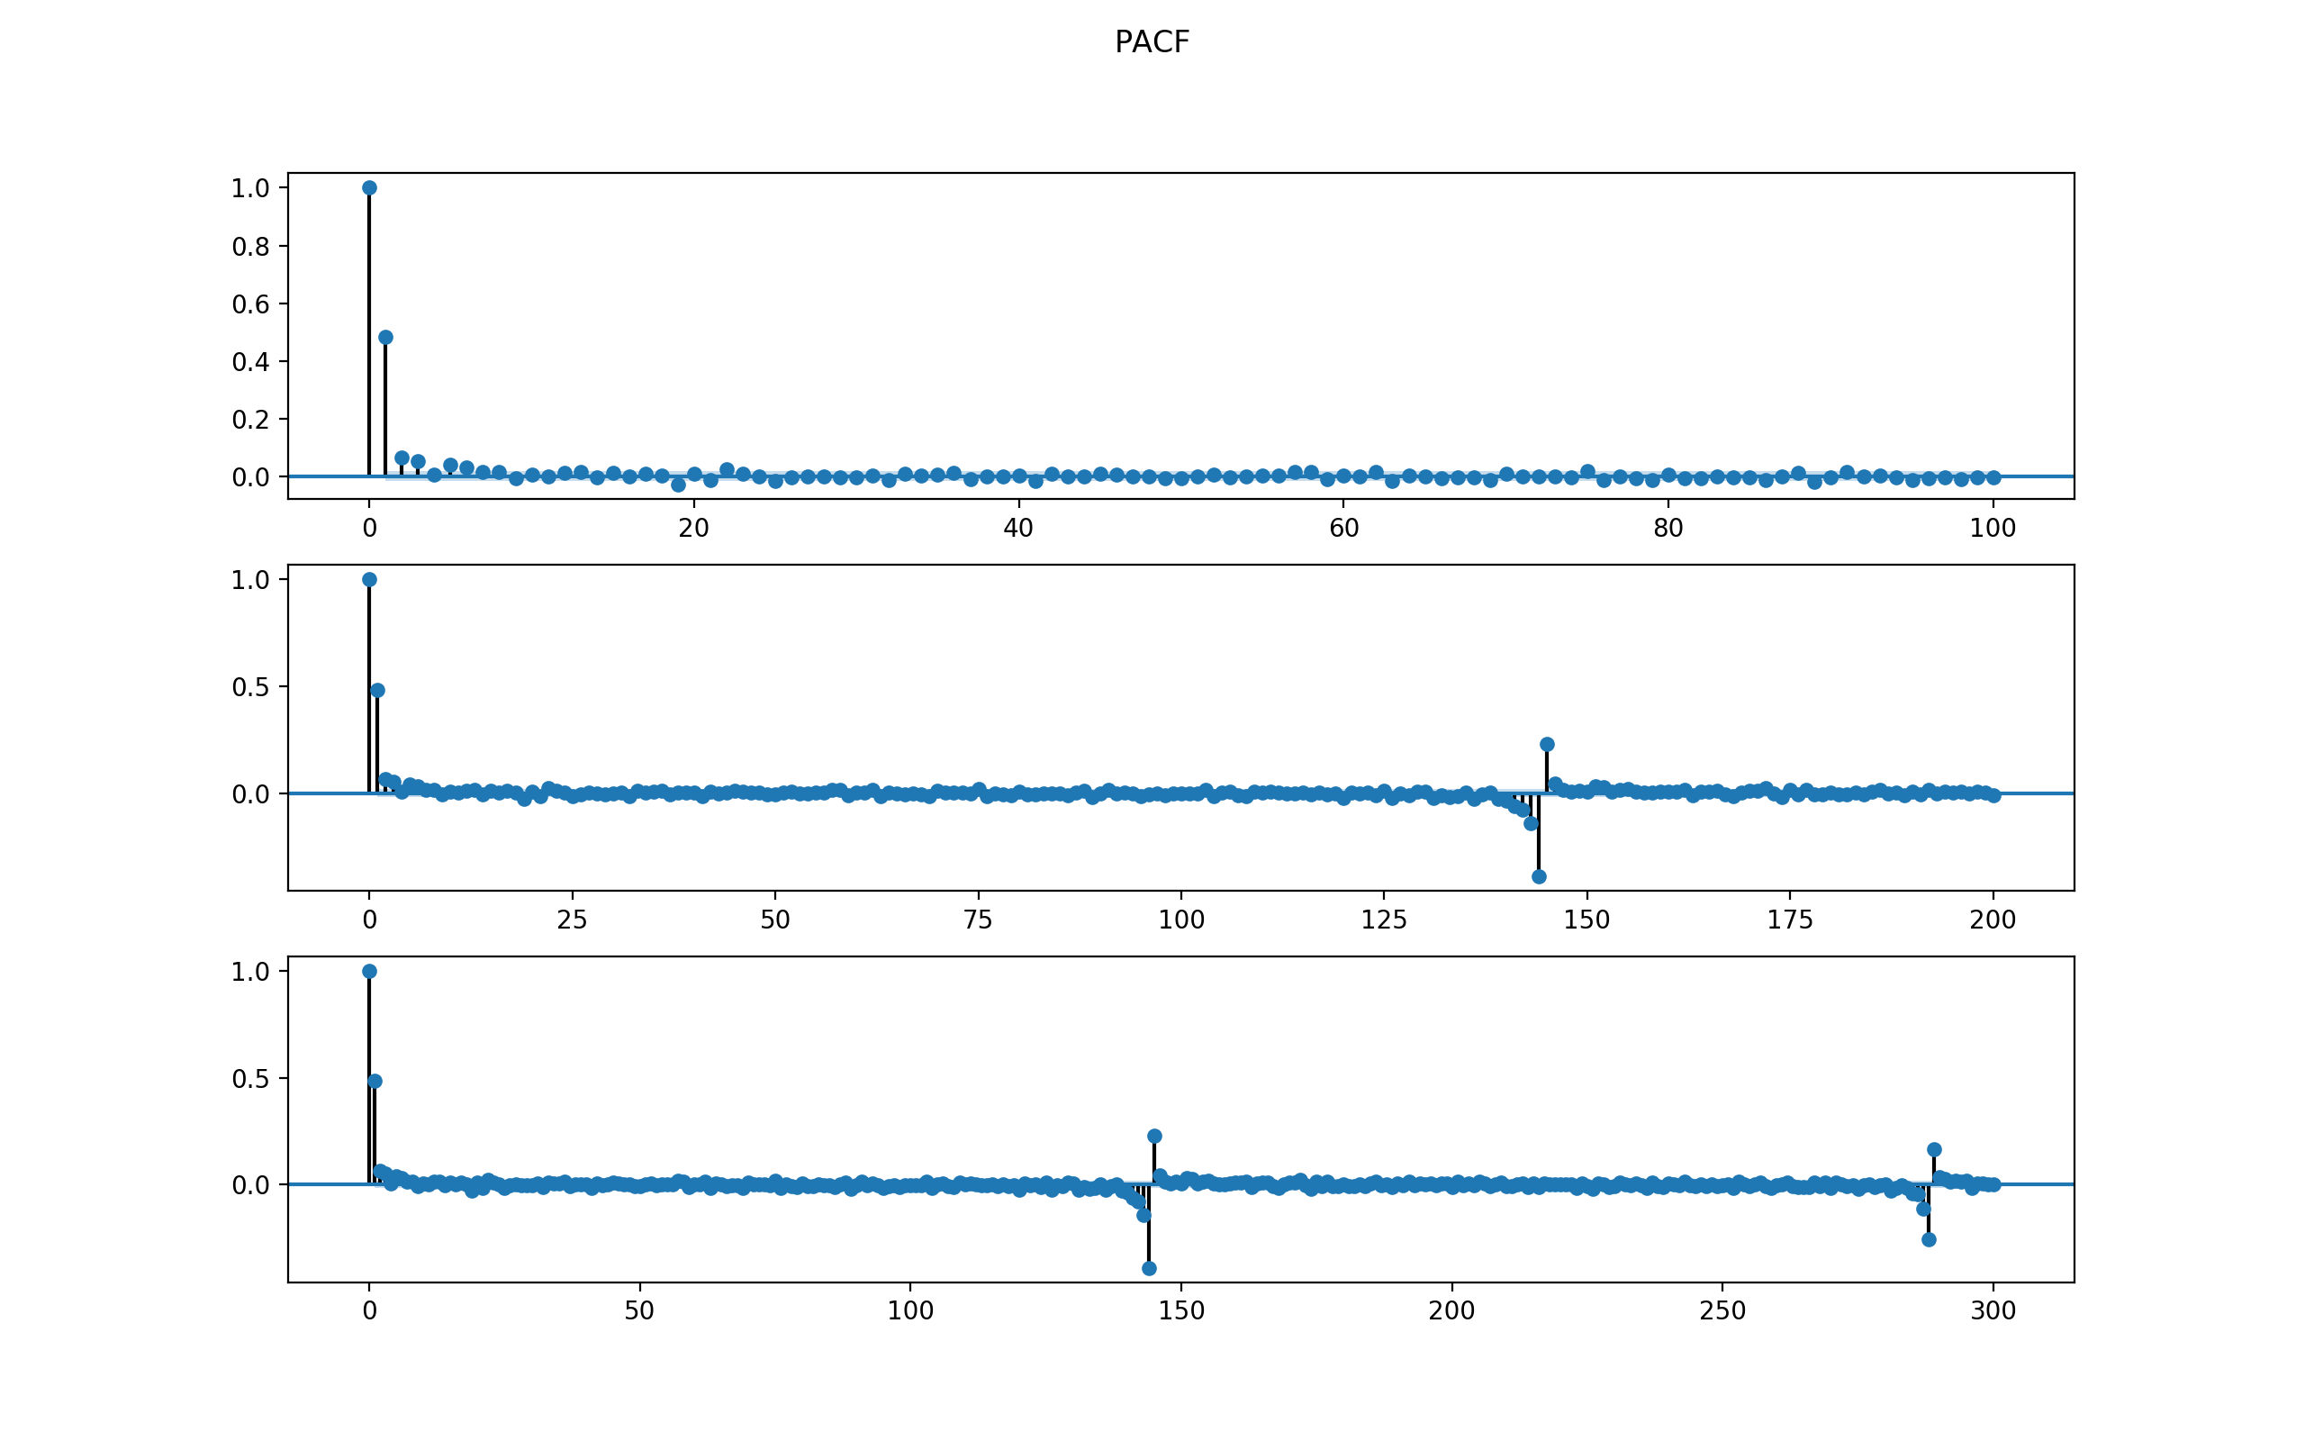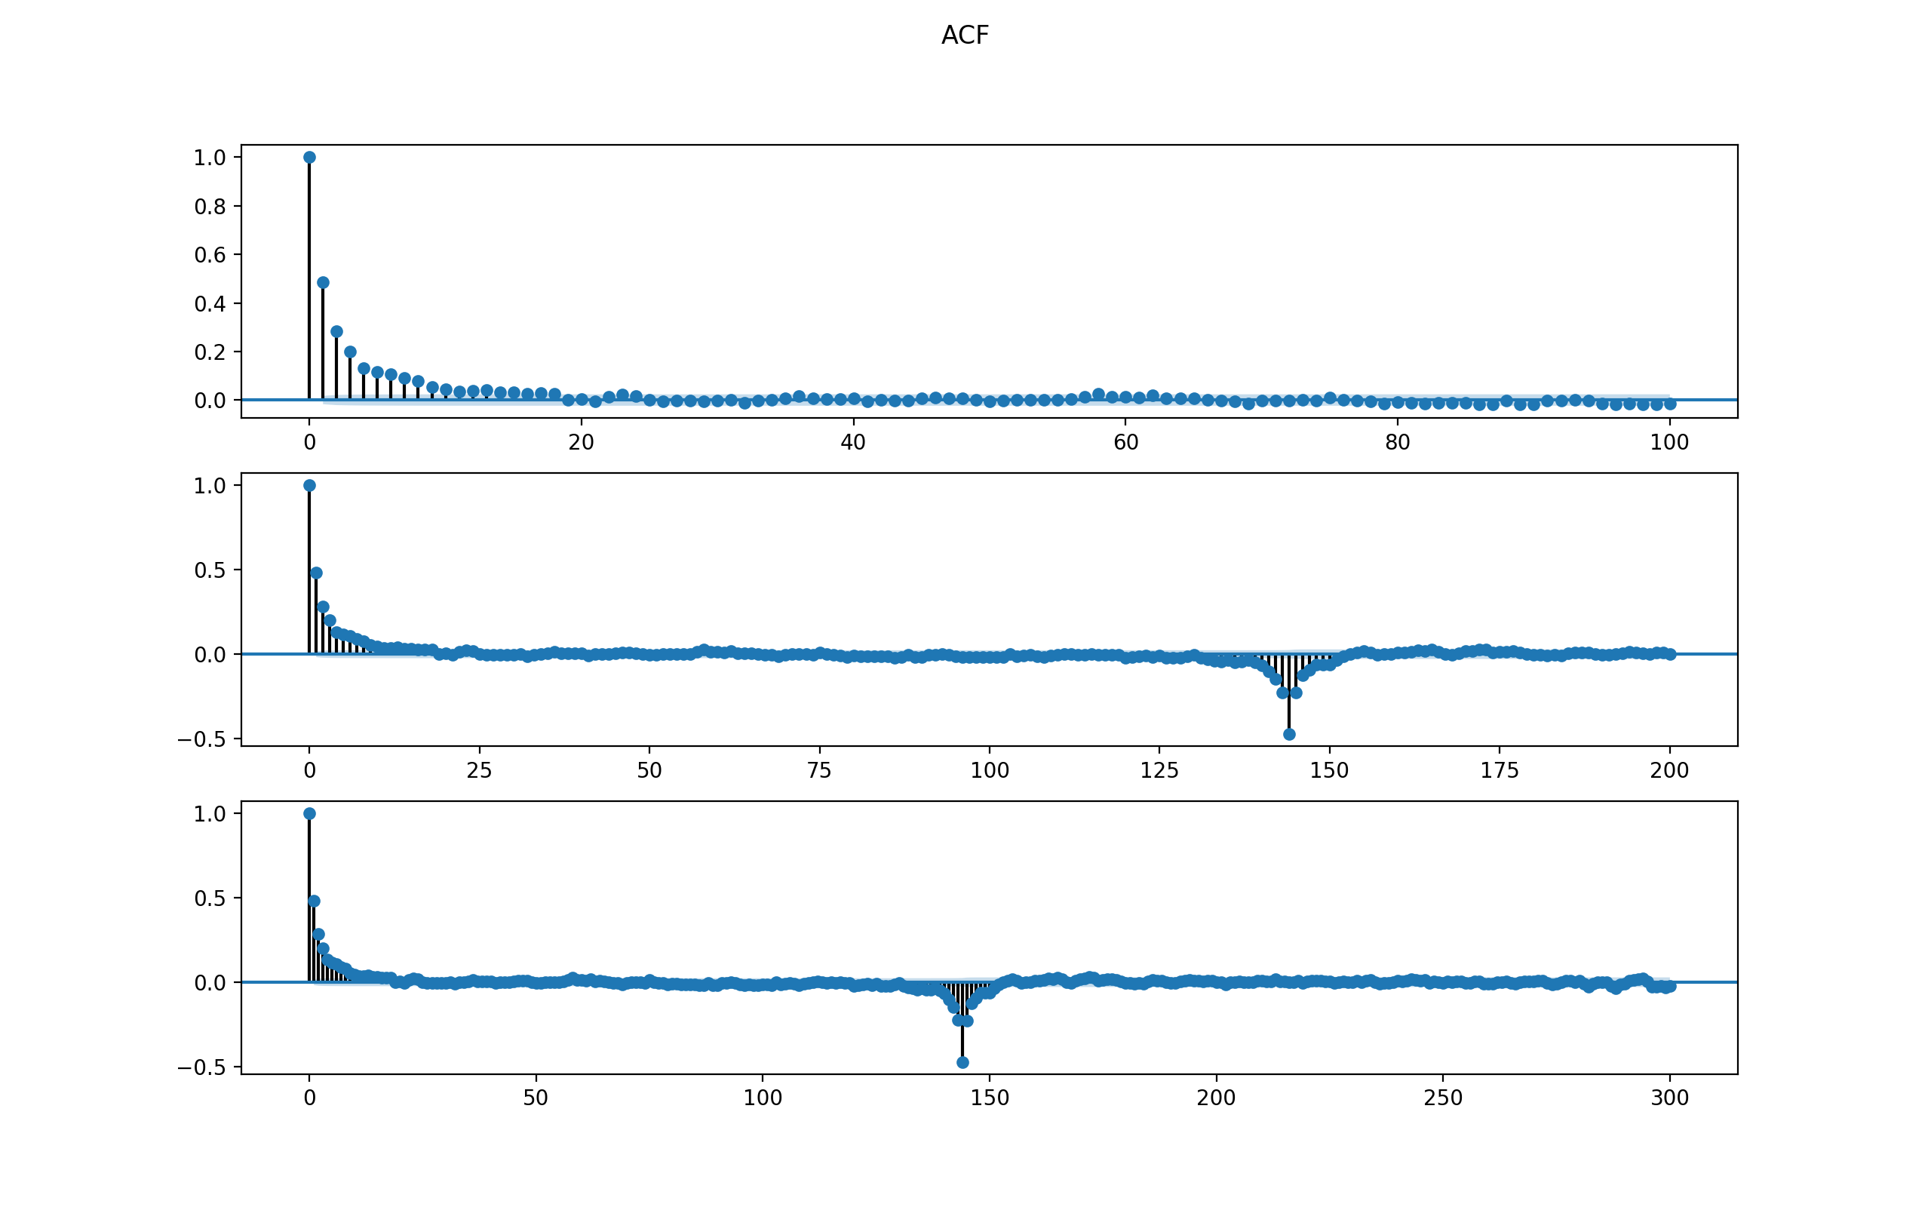

Observations:

1. PACF cut off after lag 1.

Thus, the model might be an AR(1).

ARMA Model Results

==============================================================================

Dep. Variable: Speed No. Observations: 8544

Model: ARMA(1, 0) Log Likelihood -15887.390

Method: css-mle S.D. of innovations 1.554

Date: Mon, 11 Dec 2017 AIC 31780.779

Time: 15:37:46 BIC 31801.938

Sample: 08-02-2014 HQIC 31787.998

- 09-30-2014

===============================================================================

coef std err z P>|z| [0.025 0.975]

-------------------------------------------------------------------------------

const 0.0017 0.032 0.052 0.958 -0.060 0.063

ar.L1.Speed 0.4673 0.010 48.858 0.000 0.449 0.486

Roots

=============================================================================

Real Imaginary Modulus Frequency

-----------------------------------------------------------------------------

AR.1 2.1400 +0.0000j 2.1400 0.0000

-----------------------------------------------------------------------------

ARMA Model Results

==============================================================================

Dep. Variable: Speed No. Observations: 8544

Model: ARMA(2, 1) Log Likelihood -15860.025

Method: css-mle S.D. of innovations 1.549

Date: Mon, 11 Dec 2017 AIC 31730.050

Time: 15:37:56 BIC 31765.315

Sample: 08-02-2014 HQIC 31742.081

- 09-30-2014

===============================================================================

coef std err z P>|z| [0.025 0.975]

-------------------------------------------------------------------------------

const 0.0017 0.039 0.043 0.966 -0.075 0.078

ar.L1.Speed 1.1908 0.055 21.472 0.000 1.082 1.299

ar.L2.Speed -0.2968 0.031 -9.589 0.000 -0.357 -0.236

ma.L1.Speed -0.7530 0.053 -14.316 0.000 -0.856 -0.650

Roots

=============================================================================

Real Imaginary Modulus Frequency

-----------------------------------------------------------------------------

AR.1 1.1968 +0.0000j 1.1968 0.0000

AR.2 2.8150 +0.0000j 2.8150 0.0000

MA.1 1.3280 +0.0000j 1.3280 0.0000

The final chosen model is AR(1) because 1) the PACF follows such pattern and 2) it has similar BIC compared to more complicated ARMA(2, 1) model and 3) it has fewer number of parameters.

Check the residuals to see if the model makes sense.

For AR(1) model for SEG1, the 4-plot of residuals are below.

The MSE is 14463.247007975242.

The conclusion is that the residuals are not normal. Thus ARMA(1) might not be a good fit.

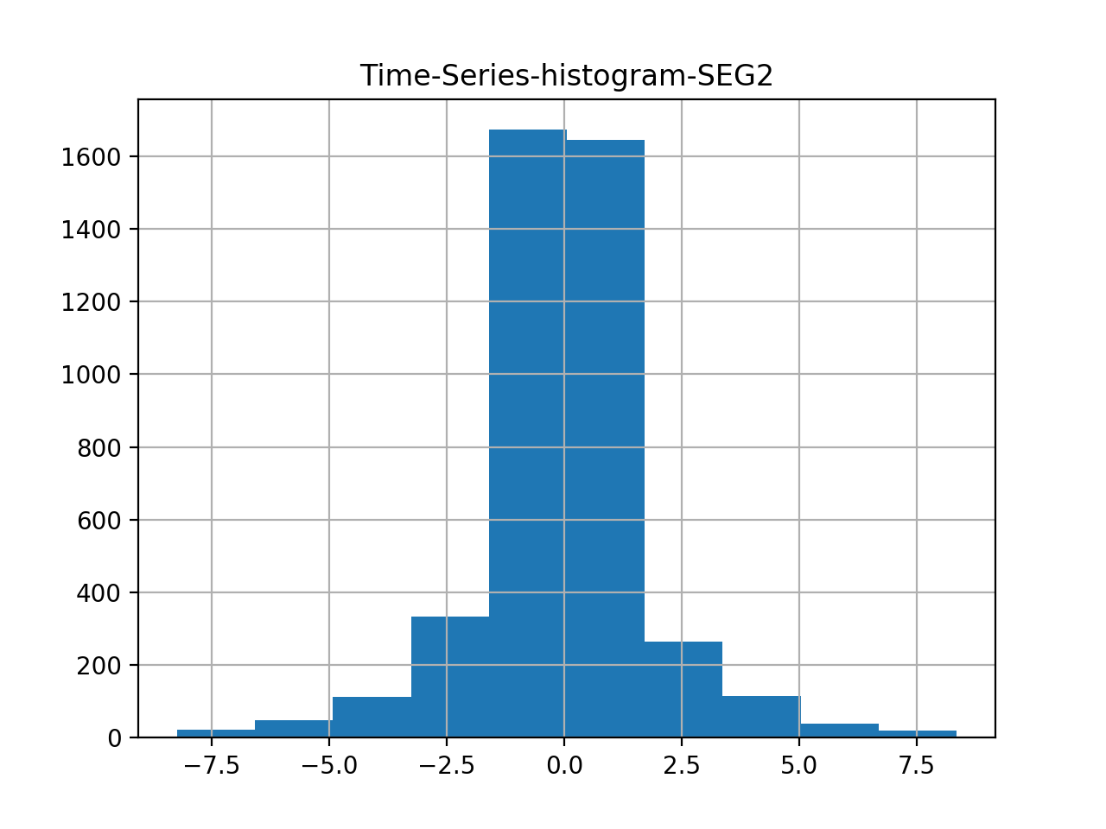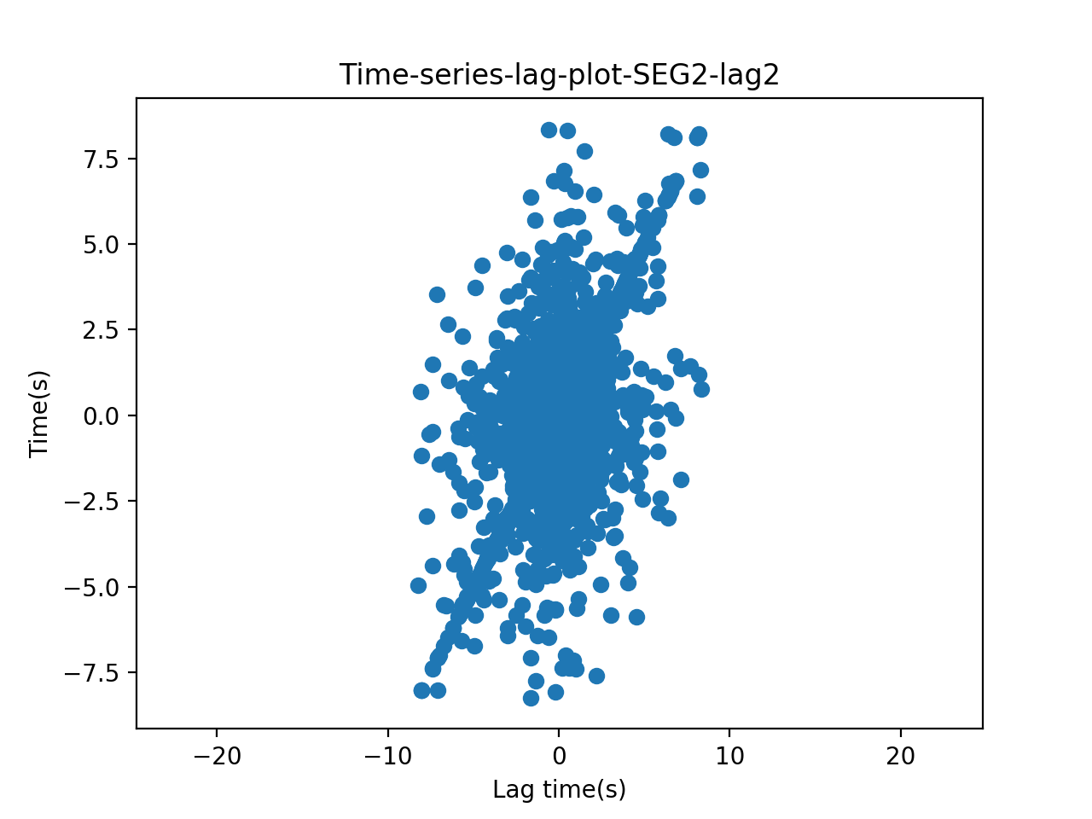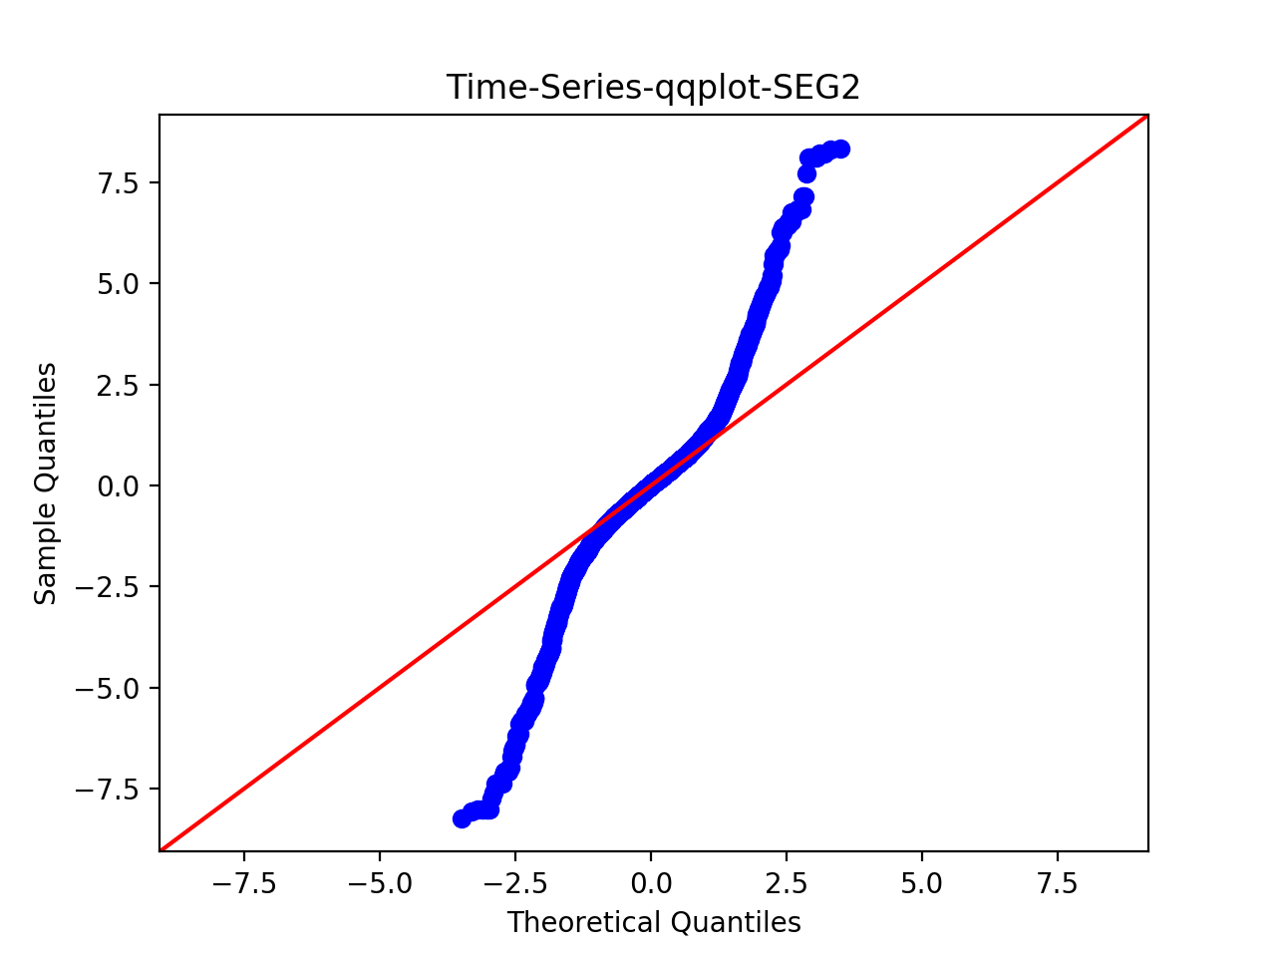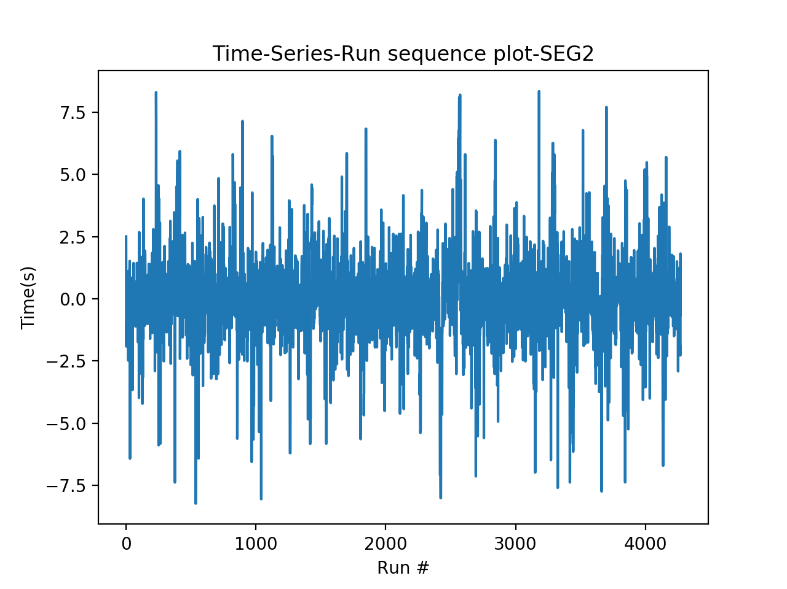

Use Chi-square goodness of fit and set number of bins = 200, results:

Power_divergenceResult(statistic=29954.044985941895, pvalue=0.0)

The p-value is smaller than 0.05, thus reject null. Thus there is a significant difference between the two data series – thus this model is not a good fit.

# Step 3: Test for OLS regression model, using mllib.

Data transformation: to run regression, since previous fit an AR(1) model, now use past day’s value as features.

For training data, the mean Squared Error = 2.41534193986

For test data, Mean Squared Error = 2.49416930584

This seems to be a good fit.

Thus, use MLlib for chi-square test returns the following results:

>>> pearson.pValue

0.0

>>> pearson.statistic

inf

Conclude that regression on a single past value is not a good fit, but the MSE value is small.

# Step 4: Test for Ridge regression model, using mllib.

Again using past three day’s value as feature.

For training data, the mean Squared Error = 2.41534193986

For test data, Mean Squared Error = 2.49416930584

The goodness of fit value:

>>> pearson.pValue

0.0

>>> pearson.statistic

inf

Conclude that ridge regression on a single past value is also not a good fit, although the MSE values are small.

# Step 5: Test for Lasso regression model, using mllib.

Again using past three day’s value as feature.

For training data, the mean Squared Error = 2.41534193986

For test data, Mean Squared Error = 2.49416930584

Thus, use MLlib for chi-square test returns the following results:

>>> pearson.pValue

0.0

>>> pearson.statistic

inf

Conclude that Lasso regression on a single past value is also not a good fit.

Conclusion for Step 3 – Step 5:

Ridge, OLS, and Lasso seem to generate similar results. The MSE for test set is 2.49416930584

AR(1) model, the MSE for test data is 14463.247007975242.